**Upper Colorado River Commission   
312th Regular Meeting – Draft Meeting Agenda**

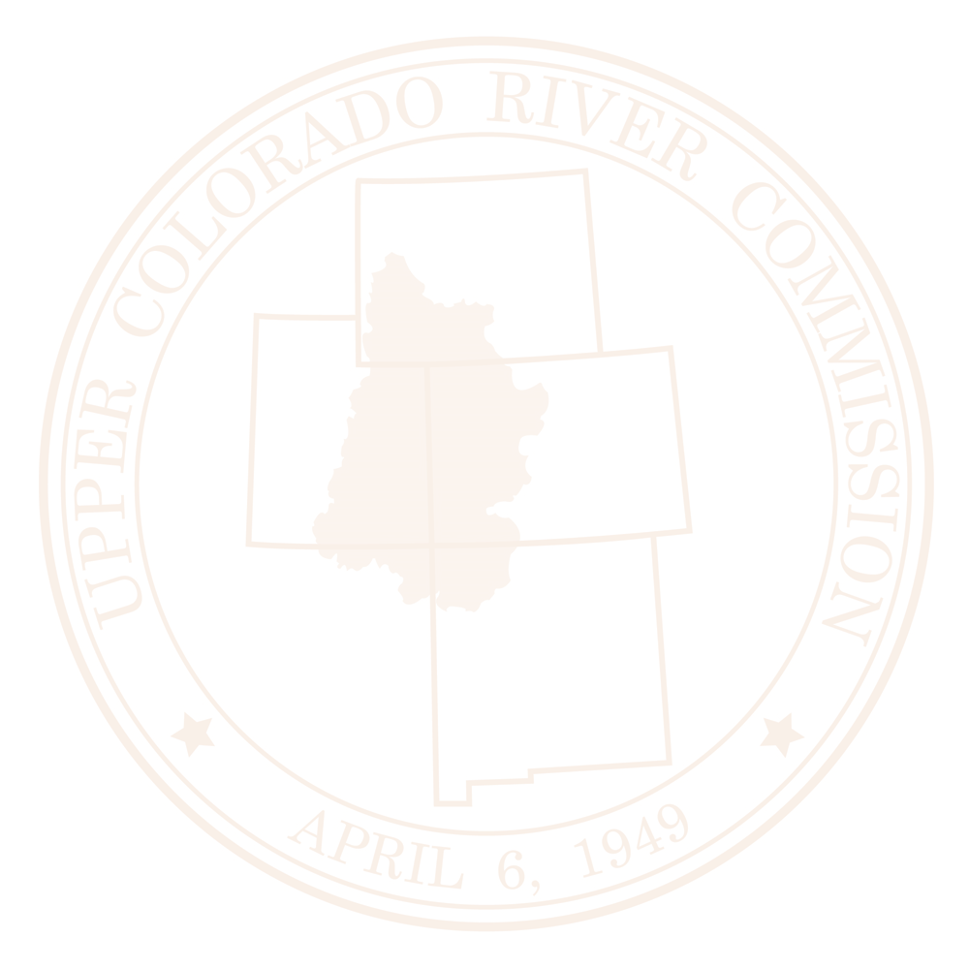June 26, 2025

9:00 am – 1:00 pm

Salt Lake City, UT

[Virtual Option](https://us02web.zoom.us/j/88000625311?pwd=kSxpstR7AWrS24jGJibbOVB9cupPn1.1)

1. Call the meeting to order – Roll Call - Introductions – Chair Mitchell and Alyx Richards
   1. Host Welcome – Utah Commissioner Gene Shawcroft
2. Conformance of the meeting to the Commission By-Laws – Director Chuck Cullom
3. Approval of the Minutes – Chair Mitchell
   1. 310th Regular Meeting of the Upper Colorado River Commission, December 4, 2024
   2. 311th Special Meeting of the Upper Colorado River Commission, June 26, 2024
4. Discussion and Request for Approval of the Treasurer’s Report and FY 2026 and Tentative FY 2027 Budgets – Director Cullom and Commissioner Shawcroft, Budget Committee Chair
5. Report of the Chair – Chair Mitchell
6. Report of the Commissioners – UCRC Commissioners
7. Engineering Committee Report – Deputy Director Rachel Musil
8. Report of the Executive Director – Director Cullom
   1. Consumptive Uses & Losses Methods Manual
   2. Provisional Accounting MOU
   3. Update on Hydrologic Shortage Quantification
   4. DROA Update
   5. Communications Update
9. Report from Reclamation – Regional Director Wayne Pullan
10. BIL/IIJA Update – Deputy Director Musil
11. Update on the Tribes-States Dialogue – Alyx Richards
12. Update on Upper Basin Recovery Programs – Michelle Garrison
13. Glen Canyon Dam Operations Update – Reclamation
14. Next Meeting
    1. 313th Special Meeting – Fall 2025
15. Other Business
16. Adjourn