Assessing Agricultural Consumptive Use in the Upper Colorado River Basin

Phase 3

2018 IRRIGATION YEAR
DRAFT REPORT

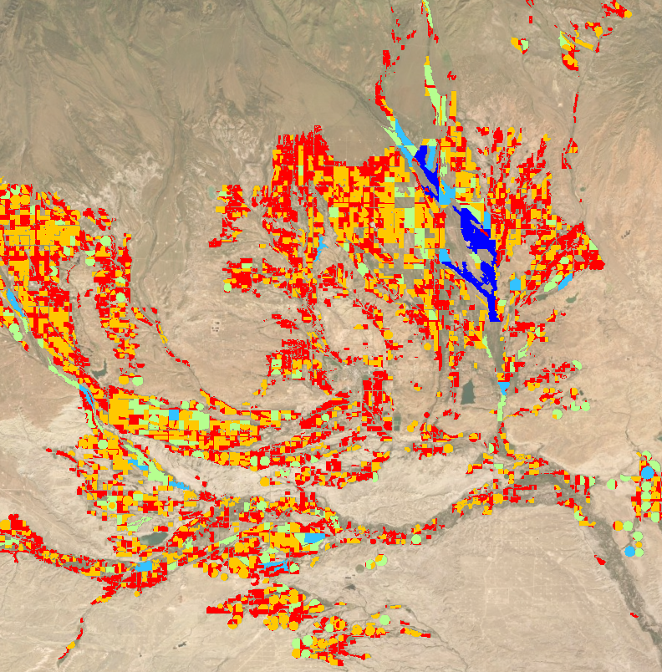

October 2019
Table of Contents
Definitions 4
Acronyms 5
1.0 Introduction 6
2.0 Background 7
2.1 Eddy Covariance Towers 7
2.2 Remote Sensing Models 10
2.2.1 METRIC Remote Sensing Method 11
2.2.2 SSEBop Remote Sensing Method 12
2.3 Crop Coefficient Methods 12
2.3.1 Modified Blaney-Criddle Potential ET 13
2.3.2 Penman-Monteith Potential ET 14
2.3.3 Effective Precipitation Estimates for Crop Coefficient Methods 14
2.3.4 Indicator gage method Applied to Crop Coefficient Methods 15
3.0 Consumptive Use Comparison Approach 16
3.1 Actual ET Comparison at Eddy Covariance Tower Approach 17
3.2 Basin-wide Crop Consumptive Use from Irrigation Comparison Approach 18
3.3 Comparison of Crop Consumptive Use from Irrigation for CCMs by Elevation Approach 19
4.0 Consumptive Use Comparison Results 19
4.1 Actual ET Comparison at the Eddy Covariance Towers 19
4.1.1. Daily ETa Comparison –EC Tower to Remote Sensing Methods 19
4.1.2 Monthly ET_{a} Comparison – EC Tower to Remote Sensing and CCMs 30
4.1.3 Growing Season ET_{a} Comparison – Palisade EC Tower to Remote Sensing and CCM Methods 35
4.2 Basin-wide Crop Consumptive Use from Irrigation 36
4.3 CCM Comparison to Modified Blaney-Criddle without an Elevation Adjustment 50
4.4 Vernal EC Tower 2017 to 2018 Comparison 51
5.0 Cost and Time Comparison 53
6.0 Summary 54
8.0 Next Steps 55
References 56
A.1. METRIC Report
B.1. SSEBop Report
C.1. Modified Blaney-Criddle Report
D.1. Penman-Monteith Report
E.1. Historical and Current Use of the Indicator gage method
F.1. Eddy Covariance Tower Data Processing Procedures

Definitions
The following defines key terms used throughout the Report.

Actual Consumptive Use from Irrigation Water (CU_{irr}): the volume of diverted irrigation water that is removed from available supplies through conversion of liquid to vapor due to evapotranspiration or harvested with the crop

Actual Evapotranspiration (ET_{a}): the rate of water that is removed from available supplies, from both irrigation and precipitation, through a combination of evaporation and transpiration from vegetation

Crop Irrigation Water Requirement (CIR): the quantity of water required from an irrigation source, in addition to precipitation, to grow a well-watered crop under optimal conditions

Effective Precipitation (P_{e}): the portion of total precipitation that is available for crop consumption

gridMET: a dataset of daily high-spatial resolution (~4-km, 1/24th degree) surface meteorological data covering the contiguous United States from 1979 to current

Potential Evapotranspiration (ET_{p}): the amount of water that is required to grow a well-watered crop under optimal conditions having a full water supply from irrigation and precipitation

Reference Evapotranspiration (ET_{r}): Potential ET from a defined, standardized reference crop that is actively growing and is at full cover and standardized height

Acronyms

CU_{irr} – Crop Consumptive Use from Irrigation

CCM – Crop Coefficient Methods

CUWG – Consumptive Use Working Group

EC Tower – Eddy Covariance Tower

ET – Evapotranspiration

ET_{a} – Actual Evapotranspiration

ET_{p} – Potential Evapotranspiration

ET_{r} – Reference Evapotranspiration

ET_{r}F – Fraction of hourly reference ET

LST – Land Surface Temperature

METRIC – Mapping EvapoTranspiration at high Resolution with Internal Calibration

QA/QC – Quality Assurance and Quality Control

SSEBop – Simplified Surface Energy Balance – Operational

UCRB – Upper Colorado River Basin

USGS – United States Geological Survey

1.0 Introduction
The Upper Colorado River Commission (Commission); the four states of the Upper Division; and the Upper Colorado Region and Denver Office of the Bureau of Reclamation (Reclamation), collectively referred to as the Consumptive Use Work Group (CUWG), are developing a coordinated program to improve timelines, accuracy, support, and cost effectiveness of agricultural consumptive use estimates across the entire Upper Colorado River Basin. Phase 1 of the study identified current methodologies used by the states and Reclamation and included suggestions for improvements. Phase 2 of the study identified improvements that could be made in collection of agricultural evapotranspiration (ET) data by expanding the meteorological network and conducted preliminary studies to evaluate remote sensing methodologies and their feasibility for use in the Upper Colorado River Basin (UCRB).

This report documents the efforts and findings of Phase 3 of the study. The Phase 3 objectives were to (1) develop and communicate sufficient detailed information and recommendations about selected remote sensing methods; and (2) compare the Blaney-Criddle and Penman-Monteith based methods for estimating potential and actual ET from irrigated lands in the UCRB.

Phase 3 included an independent evaluation and comparison of estimated potential and actual ET compared to site-specific measured consumptive use from irrigation (CU_{irr}), and a comparison of estimated CU_{irr} for the UCRB. As shown in Figure 1, two different approaches for estimating ET were investigated: (1) Remote Sensing thermal based ET models (Remote Sensing) and (2) Crop Coefficient Methods (CCM). Two Remote Sensing models were compared: METRIC (Mapping EvapoTranspiration at high Resolution with Internal Calibration) and SSEBop (Simplified Surface Energy Balance – Operational), and two CCMs were compared: Modified Blaney-Criddle with an Elevation Adjustment and Penman-Monteith. Eddy Covariance Towers (EC Towers) were installed in each state to measure ET directly for comparison to the results from the different approaches investigated. This report compares the results of the different methods and evaluates the processes, costs, and resource requirements to estimate CU_{irr} for each method for the 2018 irrigation season.

Remote Sensing Methods
METRIC
SSEBop
Crop Coefficient Methods
Blaney-Criddle
Penman-Monteith
Figure 1. Estimated ET approaches evaluated for Phase 3

Reclamation calculates crop consumptive use from irrigation for the UCRB on an annual basis and provides the results as part of the UCRB Consumptive Uses and Losses Report. Reclamation currently uses Modified Blaney-Criddle without an elevation adjustment and shortage criteria as the basis for estimating crop consumptive use. The accuracy, processing time, and resource requirements associated with each method investigated were compared to those associated with Reclamation’s current method.

2.0 Background
The following provides background on the datasets developed and used in the Phase 3 analyses.

2.1 Eddy Covariance Towers
The eddy covariance approach used in this project is considered the gold standard for measuring the key fluxes from a surface including momentum, heat, water vapor, and carbon dioxide (CO₂). It is the only method allowed for the global network of water and carbon flux estimates (https://fluxnet.fluxdata.org/about/). The systems employed in the four locations in the UCRB include three-dimensional sonic anemometers and fast-response open-path infrared gas analyzers. When sited properly, these measurements, along with a number of additional analyses, yield the flux of water vapor (ET). Several additional measurements are also useful to verify the reliability of the ET values including net radiation (incorporating incoming and outgoing components of radiation), soil temperature, soil water content, soil heat flux, air temperature, and dew point temperature. Weather data, including precipitation and mean horizontal winds, are also collected. Figure 2 shows a photograph of one the EC Tower station at Vernal, Utah.

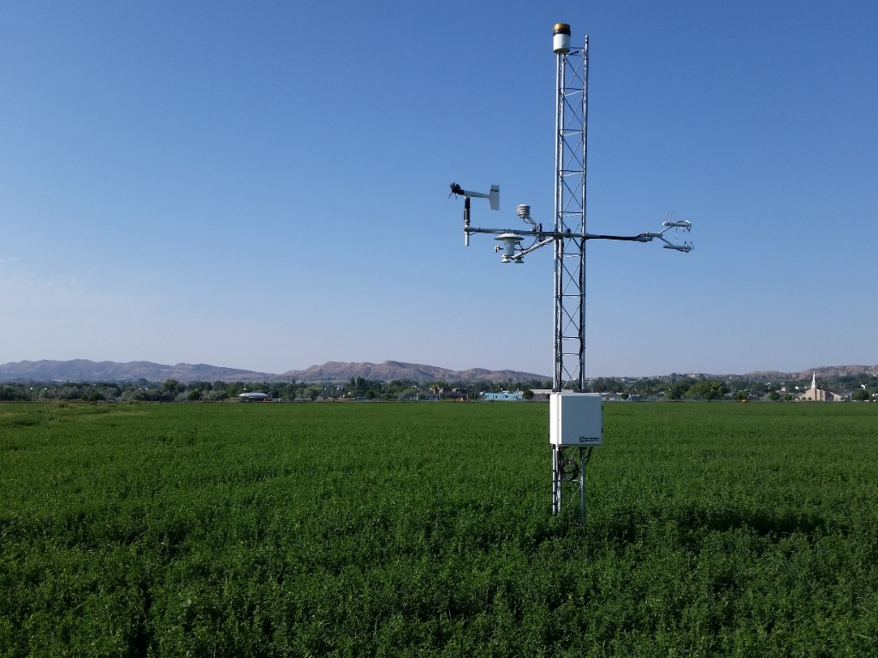
Figure 2.Eddy Covariance Tower at Vernal, Utah

For accurate ET measurements, the field must be large enough such that the measurements characterize an appropriate “footprint” or region including only the surface desired. Many other factors can affect the uncertainty of the ET measurements, including wind directions relative to the surface; non-ideal atmospheric conditions; and data and sensor quality assurance and quality control (QA/QC).

Although an exact determination of the uncertainty of eddy covariance estimates of ET is not possible, various studies have determined the approximate magnitude of some key sources of errors. The replication ability of identical towers was quantified by Alfieri et al. (2011). Kosugi and Katsuyama (2006) and Scott (2010) compared seasonal values of ET from eddy covariance to values obtained from the soil water balance. Independent measurements of available energy (net radiation minus soil heat flux) have also been used to check the ability of the sensible and latent heat flux estimates to remove the available energy at the surface. Often, both sensible and latent heat fluxes must be increased so that their sum equals the available energy at the surface (Twine et al., 2000).

The sum of published research on uncertainty of eddy covariance suggests that under optimal situations (best practices followed by experienced investigators, at ideal sites) daily, monthly and seasonal levels could be within 10 percent of actual values. This corresponds to the EC Tower measurement uncertainty reported by Allen et al. (2011) of 10 to 15 percent of actual values.

One EC Tower was installed in each of the four Upper Division states in 2017 (Figure 3). All four were operational for the 2018 growing season and used in this report. The location, elevation, crop type, and irrigation method for the four EC Towers are shown in Table 1.
Table 1. Descriptions of the Four EC Towers
Station Name | State | Elevation (ft) | Crop Type | Irrigation Method
Palisade | Colorado | 4,742 | Peach Orchard | Ground Sprinkler
Bloomfield | New Mexico | 5,563 | Grass/Alfalfa Mix | Side Roll Sprinkler
Vernal | Utah | 5,464 | Alfalfa | Side Roll Sprinkler
Big Piney | Wyoming | 6,990 | Foxtail Grass | Flood Irrigation

Standard maintenance and calibration procedures at all four sites, as well as QA/QC and data analyses, allowed these results to be confidently used for 2018. Daily EC Tower data from the four stations include a data quality rating of either “Good”, “Fair”, or “Poor”. Dates of precipitation, irrigation, and crop cutting were all noted.

  - 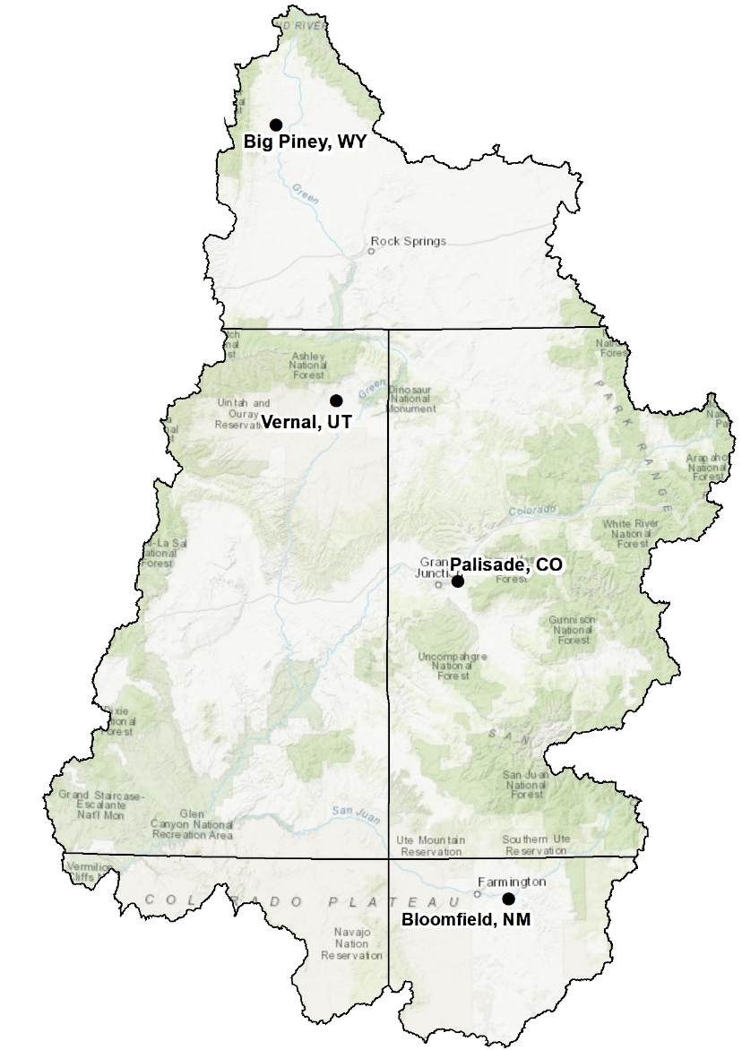
Figure 3. 2018 EC Tower Locations

2.2 Remote Sensing Models
Two thermal based ET models were used in Phase 3: SSEBop and METRIC. Both models used 2018 remotely sensed imagery from the Landsat 7 and 8 satellites to produce spatial maps of monthly total actual ET on a 30m by 30m pixel basis across the entire UCRB. The spatial maps were overlaid onto UCRB irrigated polygons. All upper division states develop irrigated acreage polygons typically either on an annual basis or every five years. Each state provided irrigated acreage polygons for use with this project.

The two Remote Sensing models are thermally-based and compute at least one component of the surface energy balance i.e., net radiation (Rn), soil heat flux (G), sensible heat flux (H) and/or latent heat flux (LE). Thermal-based ET models are able to estimate ET_{a}, reflecting crop consumptive use from available water sources (precipitation and irrigation). Water supply availability is captured in the estimates, unlike potential ET (ET_{p}) calculated using crop coefficient methods.

Accuracy of remote sensing models is dependent on several variables, and can be affected by environmental conditions, weather data used by the models, model calibration, and operator expertise. METRIC results have been compared to lysimeter measurements and shown to produce similar results (Tasumi et al, 2005; Allen et al, 2007). According to Allen et al, 2011, the typical uncertainty of thermal based remote sensing models is 10 to 20 percent both monthly, and seasonally. Similarly, SSEBop results have been shown to perform well against lysimeter and eddy covariance data sets (Gowda et al, 2009; Senay et al., 2013,2016; Velpuri et al, 2013). The size of the thermal image pixels (100m x 100m for Landsat 8 and 60m x 60 m for Landsat 7) versus the size of the non-thermal pixels (30m x 30m) can also cause minor errors in ET estimates, especially affecting tightly packed fields with different crop types. The UCRB generally consists of parcels with homogenous crop types.

2.2.1 METRIC Remote Sensing Method
Remote Sensing Methods
METRIC
SSEBop
The METRIC ET model was developed at the University of Idaho (Allen et al. 2007 a,b; 2011), and is currently one of the most widely used ET models. The model utilizes satellite image data acquired in the visible through shortwave infrared and thermal infrared portions of the electromagnetic spectrum to compute all four components of the energy balance for every pixel in the image. METRIC is calibrated using weather data from a nearby weather station such that hourly ET for a selected vigorous, full canopy agricultural field equals some multiple of hourly reference ET (ET_{r}; usually 1.05) calculated from the weather station data. An ET_{r}F (fraction of hourly reference ET) image is generated by dividing the calculated hourly ET by the hourly reference ET at the time of satellite overpass, and then these ET_{r}F values are multiplied by daily ET_{r} to generate daily ET_{a} estimates. The METRIC technical report for Phase 3 efforts is included in Appendix A and provides more detailed information on the process, calibration efforts, and ET results.

2.2.2 SSEBop Remote Sensing Method
Remote Sensing Methods
METRIC
SSEBop
The SSEBop ET model was developed by the United States Geological Survey (USGS) (Senay et al. 2013, 2016, 2017). It is an operational parameterization of the Simplified Surface Energy Balance (SSEB) model (Senay et al., 2007). Unlike METRIC, it is a partial energy balance model that only solves for the latent heat flux component at a daily time scale using a Satellite Psychrometric Approach (Senay, 2018). The SSEBop model estimates ET fraction (ETf) as a linear function of a pixel’s temperature (dry bulb) between two extremes: the land surface temperature (LST) of a well-watered, vigorous agricultural field (wet bulb), and a bare field (dry limit) producing zero ET. The difference in temperature between these two extremes is pre-calculated on a daily basis for every 1 km² in the contiguous United States assuming an average-sky condition for net radiation and weather variables (Senay, 2018). The LST of the well-watered field is estimated as a scalar multiple of gridded maximum daily air temperature data. A scaling coefficient (c factor) between these two datasets (air and surface temperatures) is automatically calculated for each Landsat scene as the ratio of LST of well-watered, vigorous agricultural fields to their associated gridded maximum air temperature values. Daily actual ET is then calculated as the product of ETf and daily reference ET. The SSEBop technical report for Phase 3 is included in Appendix B and provides detailed information on the process and ET results.

In 2018, SSEBop and METRIC did not use the same set of Landsat Satellite images; however both used similar cloud filtering methods for their analysis. Total monthly ET_{a} using both Remote Sensing methods was calculated for each UCRB irrigated acreage polygon. To allow direct comparison to the CCMs, the UCRB irrigated acreage polygons were split at gridMet grid cell boundaries.

2.3 Crop Coefficient Methods
Two crop coefficient methods were employed for Phase 3 to estimate potential consumptive use of crops; Penman-Monteith and Modified Blaney-Criddle with an Elevation Adjustment. ET from crop coefficient methods represents potential crop ET, i.e. the maximum the crops could use if they had a full supply from a combination of precipitation and irrigation.

2.3.1 Modified Blaney-Criddle Potential ET
Crop Coefficient Methods
Blaney-Criddle
Penman-Monteith
Modified Blaney-Criddle is calculated on a monthly time step and requires only monthly average air temperature and daylight hours to determine ET_{p}. Because of the minimal data requirements, data availability often dictates the use of Modified Blaney-Criddle. Modified Blaney-Criddle, as outlined in SCS Technical Release 21 (USDA, 1967), has been widely used around the world; despite studies showing it to be less accurate than other methods (ASCE Manual 70, 1990 and 2016).

A standard elevation adjustment was applied to the Modified Blaney-Criddle results in order to better represent climate conditions at higher elevations (Pochop et al., 1983). When implementing an elevation adjustment, ET_{p} is increased by 10 percent for every 1,000 meters in elevation above sea level or above the location where the crop coefficients for the specific crop were developed. Without additional information, the crop coefficients were assumed to be developed near sea level. Currently, Reclamation calculates consumptive use for the Consumptive Uses and Losses Reports using Modified Blaney-Criddle without an elevation adjustment. Several entities, including the state of Colorado, apply an elevation adjustment to the Modified Blaney-Criddle method when estimating ET_{p}.

The methodology for calculating Modified Blaney-Criddle for Phase 3 is outlined in SCS Technical Release 21. As noted, a standard elevation adjustment is then applied to the resulting ET_{p}. GridMET weather data were used in the calculations, and results were provided on a 1/24-degree (approximately 4 km) grid cell basis. Crop-specific ET depths were calculated for each grid cell and multiplied by the associated crop acreage within each cell to generate ET volumes. This process is described in more detail in Appendix C. UCRB irrigated acreage polygons were split at gridMet grid cell boundaries to allow for accurate calculation of crop acreages within each cell. This facilitated comparing results to those produced by Penman-Monteith and Remote Sensing methods.

2.3.2 Penman-Monteith Potential ET
Crop Coefficient Methods
Blaney-Criddle
Penman-Monteith
The ASCE Standardized Penman-Monteith equation (ASCE Manual
70, 2016) combines energy balance and aerodynamic equations to calculate ET_{p} on an hourly or daily basis. Solar radiation, wind speed and relative humidity, in addition to air temperature data, are required by the Penman-Monteith equation. Penman-Monteith is widely used and is the preferred standard method for calculating reference ET, as documented in ASCE Manual 70, as it has been compared to lysimeters and EC Towers and has outperformed other CCMs estimates of reference ET. The ET Demands software was used to calculate Penman-Monteith for Phase 3, as described in the Penman-Monteith report in Appendix D. GridMET weather data were used in the calculations, and results were provided on a 4 km grid cell basis. As with the Modified Blaney-Criddle method, crop-specific ET depths were calculated for each grid cell and multiplied by the associated crop acreage within each cell to generate ET volumes. This aggregation of results by grid cell allowed for comparison of ET results between both crop coefficient methods and both Remote Sensing methods on a 4 km spatial scale.

2.3.3 Effective Precipitation Estimates for Crop Coefficient Methods
Effective precipitation was calculated using the SCS method outlined in TR-21 (1967), consistent with the approach used by Reclamation to determine CU_{irr} for the Consumptive Uses and Losses Report. The SCS method uses total monthly rainfall and potential ET to calculate monthly effective precipitation. Total monthly rainfall was obtained from gridMET and results were provided on the same 4 km grid cell basis as ET_{p}. For the Modified Blaney-Criddle estimates, effective precipitation was calculated using the Modified Blaney-Criddle estimated ET_{p}. For the Penman-Monteith estimates, effective precipitation was calculated using the Penman-Monteith estimated ET_{p}, even though the ET Demands model includes an option that uses a different effective precipitation estimation method that incorporates soil characteristics and daily precipitation data.

The remote sensing methods determine ET_{a} from both irrigation and precipitation. Therefore, to determine ET_{a} only from irrigation sources (CU_{irr}), as required for the Consumptive Uses and Losses Report and for basin-wide comparisons to CCM results, effective precipitation needed to be removed. Again, the SCS method for effective precipitation outlined in TR-21 was chosen to be consistent and facilitate comparisons to the CCMs. ET_{p} is not determined by METRIC and SSEBop; therefore the decision was made to calculate effective precipitation for Remote Sensing methods using Penman-Monteith ET_{p,} not modified Blaney-Criddle ET_{p}. Note that on an annual basis, Penman-Monteith ET_{p} is 15 percent higher than Modified Blaney-Criddle ET_{p}, thus effective precipitation is higher when calculated using Penman-Monteith ET_{p}. The Remote Sensing methods will, therefore, show a higher effective precipitation than Modified Blaney-Criddle. This could cause inaccuracy when comparing Modified Blaney-Criddle to the Remote Sensing methods.

2.3.4 Indicator gage method Applied to Crop Coefficient Methods
To allow a direct comparison with remote sensing estimates, ET_{p} from crop coefficient methods was reduced by estimated shortages in irrigation supply (supply-limitations). The Reclamation indicator gage method, documented in Phase 1 and in more detail in Appendix E, was used to determine supply-limitations that occurred in Wyoming, Colorado, and Utah in 2018 consistent with the Consumptive Uses and Losses Report. New Mexico assumes lands irrigated from the San Juan and Animas Rivers receive a full supply, but uses their own indicator gage method to estimate shortages for about 2,500 irrigated acres along the La Plata River. For this study, however, all irrigated lands in the San Juan Basin in New Mexico were assumed to receive a full supply. This may not be a reasonable assumption given that the 2018 snowpack was well below average in the San Juan Basin, however due to the small amount of acreage (~2,500) in the LaPlata, this assumption should not make much of an impact on the results.

The indicator gage method was developed by Reclamation in the 1960s. Acreage was identified as “shorted” if it did not receive enough irrigation water to supply the crop’s irrigation water demand in any year during the study period. Shorted lands were associated with indicator stream gages and a flow threshold was determined for each gage. When the flow at the assigned stream gage drops below the threshold, the corresponding lands are assumed to no longer receive an irrigation supply. The assignment of lands to gages was made at a watershed level (approximately the scale of the USGS Hydrologic Unit Code 8 level). Note that the watersheds were also split at state lines.

There are two tiers of flow-based shortages in each watershed; one for alfalfa and one for grass pasture. When the streamflow threshold occurs, the assigned percent of shorted lands associated with the gage is assumed to not receive any irrigation supply for the remainder of the growing season, and calculation of consumptive water use ceases on that date. Alfalfa and pasture grass have different streamflow triggers in each watershed and the percent of the total acreage assigned as shorted lands varies in each watershed. In some areas, alfalfa and/or grass pasture are assumed to never be water short; therefore, the full crop requirements are always met. Crops other than alfalfa and pasture grass are assumed to receive a full supply.

Reclamation staff performed a detailed review of the shortage criteria currently used in the indicator gage method. As described in Appendix E, the criteria for Wyoming, Utah, and Colorado appear to have been either purposefully adjusted over time or have been incorrectly applied in the series of spreadsheets used by Reclamation. As noted, “The current low shortage percentages for Colorado (typically 0% shortage for alfalfa and 5% for pasture hay) seem questionable given estimates provided by the state of Colorado, the contrast to values in neighboring Utah and Wyoming (Figure 8 – 12), and the assessment of the Comprehensive Framework Study that 37% of the irrigated lands in the Upper Basin receive less than a full water supply in a typical year.” However, the lack of supply data for all states in the UCRB currently necessitates the use of the indicator gage method for the Consumptive Uses and Losses Report; therefore it is considered in the Section 4 comparisons. The comparisons in this report provide the opportunity to understand the limitations of the current method and investigate other options for estimating crop consumptive use in the UCRB.

3.0 Consumptive Use Comparison Approach
Three different comparisons of the methods were considered:

- Actual ET Comparison at the Eddy Covariance Tower. As discussed, the EC Tower directly measures ET_{a} from both irrigation and precipitation. The two Remote Sensing methods also estimate ET_{a} from both irrigation and precipitation and were compared to the EC Towers directly at daily, monthly and growing season time intervals. The CCMs were compared to the EC Towers at monthly and growing season time intervals.
- Basin-wide Crop Consumptive Use from Irrigation Comparison. The Remote Sensing methods directly estimate ET_{a} from both irrigation and precipitation. ET_{a} from Remote Sensing methods were reduced by effective precipitation to estimate CU_{irr}, and ET_{p} from the CCM estimates were reduced by both effective precipitation and limitations in irrigation supply based on the indicator gage method. Comparisons were made on a monthly and growing season time interval, both basin-wide and by state, similar to how results are provided in the Consumptive Uses and Losses Report.
- CCM Comparison of Crop Consumptive Use from Irrigation. The CCMs were compared to better understand differences between the current method used for the Consumptive Uses and Losses Report (SCS Modified Blaney-Criddle without an elevation adjustment), and the two methods investigated during Phase 3 (SCS Modified Blaney-Criddle with an Elevation Adjustment, and Penman-Monteith). The comparison considered the differences on a basin-wide scale and grouped by elevation.

Figure 4 shows the approach that was taken to post-process each dataset for the final comparisons.

Figure 4. Approach used to determine Potential ET, Actual ET, and Irrigation Consumptive Use for each method
This approach varies from the typical approach used when irrigation supply is a measured input, rather than estimated based on streamflow using the indicator gage method. Effective precipitation would normally be removed from ETp before irrigation supply is considered. However, in order to compare ETa from the CCMs to the Remote Sensing data, results had to first be reduced to reflect irrigation supply limitations, as Remote Sensing includes the effective precipitation supply. Because the indicator gage method simply “cuts off” the irrigation supply independent of the irrigation demand, the results are not impacted by changing the typical order. As noted above, the indicator gage method was only used to compare CUirr basin-wide, as site specific information was used to indicate any supply limitations at the EC Tower.

3.1 Actual ET Comparison at Eddy Covariance Tower Approach
Accuracy of ET_{a} estimates from the Remote Sensing methods at the four EC Tower sites were assessed by comparing them to measured ET_{a} at the EC Towers. Note that the accuracy of the Remote Sensing models at the towers may not be an indication of accuracy in other areas of the UCRB; however, having four tower sites in 2018 provides a range of accuracy for different crop types, elevations, and weather conditions. ET_{a} from the EC Tower and Remote Sensing methods was compared over daily, monthly, and growing season time intervals to understand and assess accuracy for each time interval. ET_{a} from Remote Sensing was determined for the area estimated to be within the EC Tower’s daily fetch, then summed for the monthly and growing season comparison. Using fetch rasters allow an estimate of the vegetation type and water availability conditions that are represented by the daily ET measurement. Appendix F describes how the fetch rasters were developed. Note that the SSEBop model produced unreliable results for the Palisade EC Tower from April 1st to May 9th; therefore results from SSEBop during that time period are not included in the comparison.

ET_{p} estimates from the two CCMs were also compared to ET_{a} measured at the EC Tower on a monthly and growing season time interval. Supply limitations were assigned to the CCM methods based on the Indicator gage method for the basin-wide comparison. Irrigator-supplied information indicated that the acreage around the Palisade, Vernal, and Big Piney EC Towers received a full supply in 2018. The Bloomfield EC Tower received a full supply until the side roll sprinkler pump became inoperable, causing irrigation to cease after the second cutting. Although the irrigator did not record when irrigation ceased, shallow soil moisture probes indicate that the crops became stressed around September 12. Without having deeper soil moisture probes it is not possible to determine the level of shortage the acreage around the Bloomfield tower experienced, therefore it was decided only to compare results up to September 12. The September CCM values were decreased by 61 percent and the Remote Sensing and EC Tower September values were summed from September 1 through September 12.

Daily EC Tower estimates were determined by computing hourly fluxes for Rn, G, H, and LE. Hourly fluxes were summed for 24 hours; the resulting daily fluxes were then adjusted for energy balance closure. Final daily fluxes were converted to daily ET using latent heat of vaporization corrected for temperature. Details on forced closure and hourly gap filling are provided in Appendix F.

3.2 Basin-wide Crop Consumptive Use from Irrigation Comparison Approach
As discussed above, effective precipitation was subtracted from the CCMs ET_{p} estimates and supply-limitations were considered using the indicator gage method to estimate CU_{irr}. Effective precipitation was subtracted from the Remote Sensing ET_{a} estimates to provide CU_{irr}, allowing a consistent basis of comparison across methods. Crop consumptive use from irrigation (CU_{irr}) was then compared basin-wide at monthly and growing season time steps.

3.3 Comparison of Crop Consumptive Use from Irrigation for CCMs by Elevation Approach
As noted above, the crop consumptive use from irrigation estimated for the annual Consumptive Uses and Losses Report is currently calculated using the SCS Modified Blaney-Criddle method without an elevation adjustment to estimate ET_{p}, removing effective precipitation based on the SCS method, and accounting for supply limitations using the indicator gage method. This method was compared to the two CCM methods used in Phase 3 to understand how CU_{irr} could change with the application of an elevation adjustment to the Modified Blaney-Criddle and with the Penman-Monteith method. Monthly total CU_{irr} for irrigated polygons was summed in defined elevation “bands”, for example between 4,000 and 5,000 feet above mean sea level.

4.0 Consumptive Use Comparison Results
The following summarizes the results of the consumptive use comparisons.

4.1 Actual ET Comparison at the Eddy Covariance Towers
ET_{a} was measured at the four EC Towers and compared on a daily basis to METRIC and SSEBop. Both the CCM and Remote Sensing methods were compared to the four EC Towers on a monthly and growing season basis.

4.1.1. Daily ETa Comparison –EC Tower to Remote Sensing Methods
ET_{a} was extracted from both METRIC and SSEBop daily raster images for an area surrounding the four EC Tower sites. The METRIC and SSEBop models produce ET_{r}F (fraction of reference ET) images for each satellite overpass date, which when multiplied by daily ET_{r}, produce daily ET_{a} images. Data gaps in Landsat 7 ET_{r}F images were filled using linear temporal interpolation from the most recent previously and subsequently acquired images with valid ET_{r}F data. Daily ET_{a} images from the Remote Sensing models are developed for every day of each month by interpolating the ET_{r}F images between satellite overpasses.

Not every satellite overpass image was used by the Remote Sensing models. Images that had high levels of cloud cover could not be used. Satellite images that were used by the Remote Sensing models should produce results that are more accurate than those between Landsat image acquisitions dates. Figures 5 to 8 show the Palisade, Bloomfield, Vernal, and Big Piney EC Tower ET_{a} data with a “Good” or “Fair” rating plotted against METRIC and SSEBop for image acquisition dates only. The linear regression equation and the coefficient of determination are shown on the graph. A perfect comparison would result in the regression equation y=x and the coefficient of determination (R²) equal to 1.

Figure 5. Remote Sensing and Palisade EC Tower Daily ET_{a} rated “Good” or “Fair” for Days of Image Acquisition

Figure 6. Remote Sensing and Bloomfield EC Tower Daily ET_{a} rated “Good” or “Fair” for Days of Image Acquisition

  - Figure 7. Remote Sensing and Vernal EC Tower Daily ET_{a} rated “Good” or “Fair” for Days of Image Acquisition

  - Figure 8. Remote Sensing and Big Piney EC Tower Daily ET_{a} rated “Good” or “Fair” for Days of Image Acquisition
ET_{a} determined from image acquisition days for SSEBop tended to be less than the EC Tower values (below the 1:1 Line) and have considerable amounts of scatter at all EC Tower locations. ET_{a} determined from image acquisition days for METRIC tended to stay near the 1:1 line and had reasonable correlations (R² close to 1) for the Bloomfield and Big Piney EC Tower sites.

It is important to understand the impact the quality rating associated with each day of data from the EC Tower has on the correlation between the daily EC Tower data and the Remote Sensing data. Therefore, figures 9 to 12 compare daily EC Tower ET_{a} data with a “Good” or “Fair” rating to the corresponding Remote Sensing data (i.e., interpolated Remote Sensing data are included) at each tower. Table 2 shows the percent of the growing season that each data quality rating occurred. Roughly 96 percent of the daily EC Tower ET_{a} data were classified as “Good” or “Fair” in 2018. Unlike 2017, EC Tower data did not require daily gap filling at any site.
Table 2. Data Quality Rating Percent of Occurrence
Data Rating | Percent of Occurrence
 | Palisade, CO | Bloomfield, NM | Vernal, UT | Big Piney, WY
GOOD | 97% | 93% | 58% | 77%
FAIR | 2% | 3% | 34% | 20%
POOR | 1% | 4% | 7% | 4%

Both the Palisade and Vernal EC Towers are covered by two Landsat Paths (Palisade 35 and 36; Vernal 36 and 37); therefore, there are two ET_{a} values for each day for METRIC at the two sites. For Figures 9 and 12, the two values were averaged to give one value unless it was an image acquisition day; then the value from the image acquired that day (either Landsat 7 or 8) was used. A daily synthesized image was provided for SSEBop for each EC Tower location in 2018; therefore the single daily value is shown in the graphs.

Figure 9. Remote Sensing and Palisade EC Tower Daily ET_{a} Comparison using only data with “Good” Or “Fair” data quality ratings

Figure 10. Remote Sensing and Bloomfield EC Tower Daily ET_{a} Comparison using only data with “Good” Or “Fair” data quality ratings

Figure 11. Remote Sensing and Vernal EC Tower Daily ET_{a} Comparison using only data with “Good” Or “Fair” data quality ratings

Figure 12. Remote Sensing and Big Piney EC Tower Daily ET_{a} Comparison using only data with “Good” Or “Fair” data quality ratings
Inclusion of interpolated Remote Sensing data corresponding to days with an EC Tower quality rating of “Good” or “Fair” increased the amount of scatter in the data shown in Figures 9 to 12 compared to Figures 5 to 8. The correlations between METRIC and the EC Tower decreased slightly when including the interpolated data at the Bloomfield and Big Piney sites; the correlations between SSEBop and the EC Tower data improved at the Palisade and Bloomfield sites.

In an ideal situation, only the “Good” or “Fair” rated EC Tower data would be used, but one of the main objectives of this report is to compare methods at monthly and growing season time intervals in order to be comparable to the current reporting format in the Consumptive Uses and Losses Report. To compare the EC Tower and Remote Sensing data on a growing season basis, all of the EC Tower daily data, regardless of the quality rating, were included as shown in Figures 13 to 16. Including all tower data regardless of quality rating did not increase the scatter in the data compared to including only “Good” or “Fair” rated measurements for either the METRIC or SSEBop comparison at any of the sites. In addition, the correlations at all stations for both METRIC and SSEBop were not negatively impacted.

  - Figure 13. Remote Sensing and Palisade EC Tower Daily ET_{a} Comparison using all data

Figure 14. Remote Sensing and Bloomfield EC Tower Daily ET_{a} Comparison using all data

  - Figure 15. Remote Sensing and Vernal EC Tower Daily ET_{a} Comparison using all data

  - Figure 16. Remote Sensing and Big Piney EC Tower Daily ET_{a} Comparison using all data
Figures 17 to 20 show daily ET_{a} from the EC Tower, METRIC and SSEBop from April 1 to October 31, 2018 for each EC Tower site. Note that due to unreliable SSEBop results for April 1 to May 9, no data is shown for that time period.

METRIC tended to be close to or lower than the two towers covered by path 35 (Palisade and Bloomfield), however it was close to or higher than the two towers covered by path 37 (Vernal and Big Piney). SSEBop tended to be lower than all the towers, although it was closer to the tower between July and August at all tower locations. Both Remote Sensing methods generally followed EC Tower ET_{a} patterns, except when SSEBop dropped to zero periodically throughout the growing season at Bloomfield and Vernal.

Precipitation and irrigation events can cause problems with the EC Tower data and could be a source of discrepancy between the Remote Sensing methods and the EC Tower data. Cuttings could have occurred between image acquisition days and would have been missed by the Remote Sensing models. This could cause a discrepancy until the next image acquisition date. Precipitation, irrigation events, and cuttings are included in Figures 17 to 20. Note that the Palisade irrigation events were estimated to occur every 10 to 15 days from user-supplied information. Based on Figures 5 through 20, it appears that METRIC estimates more closely matched the 2018 measured EC Tower data at all tower sites on a daily basis.

Figure 17. Remote Sensing and Palisade EC Tower Daily ET_{a} Comparison

Figure 18. Remote Sensing and Bloomfield EC Tower Daily ET_{a} Comparison

Figure 19. Remote Sensing and Vernal EC Tower Daily ET_{a} Comparison

Figure 20. Remote Sensing and Big Piney EC Tower Daily ET_{a} Comparison

4.1.2 Monthly ET_{a} Comparison – EC Tower to Remote Sensing and CCMs
EC Tower daily ET_{a} was summed to monthly in order to compare to both the CCM and the Remote Sensing methods. Shallow soil water measurements and user-supplied information at the Palisade, Vernal, and Big Piney towers indicated that those locations received a full supply in 2018; despite the fact that much of the UCRB acreage experienced shortages during this dryer year. Bloomfield was shorted in September and October because of a pump malfunction. As discussed above, it is unclear when the shortages began: therefore monthly and growing season comparisons do not include data from September 13 to October 31 at the Bloomfield EC Tower. Figures 21 to 24 show monthly ET_{a} estimates at each tower for all methods. The percent differences (calculated using Eq. 4) for each of the methods compared to the EC Tower are shown in Tables 3 to 6. Positive values indicate that the method resulted in higher ET_{a} compared to the EC Tower; negative values indicate that the method resulted in lower ET_{a} compared to the EC Tower.

$Percent Difference= \left(\frac{{ET}_{Remote Sesing or CCM}-{ET}_{EC Tower}}{{ET}_{EC Tower}}\right)*100$ (Eq. 4)

Figure 21. Monthly ET_{a} Estimates at the Palisade EC Tower Site

Table 3. Percent Difference of Monthly ET compared to the Palisade EC Tower measured ET_{a}
Method | April | May | June | July | August | September | October
METRIC | -5% | -1% | 0% | -15% | -13% | -16% | -21%
SSEBop | n/a | -63% | -25% | -31% | -20% | -30% | -8%
Modified Blaney-Criddle with Elev. Adj. | -1% | -27% | -27% | -14% | -17% | -33% | -14%
Penman-Monteith | 17% | 10% | 12% | -8% | -12% | -34% | 9%

The following are observations for the Palisade EC Tower based on Figure 21 and Table 3:
- Penman-Monteith and METRIC matched up closest to the EC Tower
- All methods except Penman-Monteith were typically close to or lower than the EC Tower in every month

Figure 22. Monthly ET_{a} Estimates at the Bloomfield EC Tower Site

Table 4. Percent Difference of Monthly ET compared to the Bloomfield EC Tower measured ET_{a}
Method | April | May | June | July | August | September | October
METRIC | -23% | -18% | -13% | -21% | -12% | -20%
SSEBop | -34% | -36% | -28% | -10% | -13% | -24%
Modified Blaney-Criddle with an Elev. Adj. | 15% | -21% | 5% | 13% | 13% | 14%
Penman-Monteith | 229% | 15% | 6% | -12% | -2% | 28%

The following are observations for the Bloomfield EC Tower based on Figure 22 and Table 4:
- Penman-Monteith reported large ET_{a} values in April and May compared to the EC Tower
- Both Remote Sensing methods were consistently lower than the EC Tower
- Both CCMs tended to be higher than the EC Tower, possibly indicating that there were shortages not identified by the water user

  - Figure 23. Monthly ET_{a} Estimates at the Vernal EC Tower Site

Table 5. Percent Difference of Monthly ET compared to the Vernal EC Tower measured ET_{a}
Method | April | May | June | July | August | September | October
METRIC | 47% | 11% | 7% | 25% | 6% | 12% | 17%
SSEBop | -39% | -47% | -31% | 6% | 9% | 42% | -24%
Modified Blaney-Criddle with an Elev. Adj. | -54% | -12% | 11% | 40% | 16% | -3% | -10%
Penman-Monteith | -33% | 23% | 13% | 17% | 20% | -14% | -59%

The following are observations for the Vernal EC Tower based on Figure 23 and Table 5:
- METRIC was higher than the EC Tower in every month.
- The CCMs were both higher than the EC Tower in June, July and August, potentially indicating some shortages occurred during these months.

  - Figure 24. Monthly ET_{a} Estimates at the Big Piney EC Tower Site

Table 6. Percent Difference of Monthly ET compared to the Big Piney EC Tower measured ET_{a}
Method | April | May | June | July | August | September | October
METRIC | 55% | 23% | 11% | 7% | 6% | 36% | 20%
SSEBop | -87% | -70% | -20% | 8% | -25% | -70% | -93%
Modified Blaney-Criddle with an Elev. Adj. | -100% | -29% | -28% | -2% | 4% | -20% | -100%
Penman-Monteith | -100% | -55% | 8% | 25% | 63% | -39% | -100%

The following are observations for the Big Piney EC Tower based on Figure 24 and Table 6:
- SSEBop was typically lower than the EC Tower, while METRIC was higher than the EC Tower in every month
- Both CCM methods showed no ET_{p} during April and October; most likely due to the temperature driven start and stop of the growing season used in both models

While none of the methods at any of the towers were consistently within 10 percent of the EC Tower’s assumed inherent error on a monthly basis, METRIC was within 10 percent more frequently than the other methods across all four tower locations. All of the methods performed best at the Palisade EC Tower, most likely the crop (orchard) did not require estimates of when a cutting occurred. The largest percent differences for all methods and at all locations tended to occur during April and May.

4.1.3 Growing Season ET_{a} Comparison – Palisade EC Tower to Remote Sensing and CCM Methods
Tables 7 to 10 show growing season estimated ETa for the CCMs for the Remote Sensing methods at the four tower locations and percent differences compared to the EC Tower growing season ET_{a}. As noted above the Bloomfield EC Tower results for all methods were cut off at September 12.
Table 7. ET_{a} at Palisade EC Tower and Percent Difference Compared to EC Tower ET_{a}
Method | April 1 - Oct 31 Total (inches) | Percent Difference
EC Tower | 51.3 | -
METRIC | 46.3 | -10%
SSEBop* | 33.0 | -36%
Modified Blaney-Criddle with an Elev. Adj. | 40.5 | -21%
Penman-Monteith | 49.5 | -3%
  - *SSEBop did not have reliable values for April 1 to May 9, these values
were excluded from the results and the percent difference comparison.

Table 8. ET_{a} at Bloomfield EC Tower and Percent Difference Compared to EC Tower ET_{a}
Method | April 1 – Sept 12 Total (inches) | Percent Difference
EC Tower | 38.2 | -
METRIC | 31.7 | -17%
SSEBop | 29.5 | -23%
Modified Blaney-Criddle with an Elev. Adj. | 39.9 | 4%
Penman-Monteith | 45.1 | 18%

Table 9. ET_{a} at the Vernal EC Tower and Percent Difference Compared to EC Tower ET_{a}
Method | April 1 - Oct 31 Total (inches) | Percent Difference
EC Tower | 38.2 | -
METRIC | 44.1 | 15%
SSEBop | 30.0 | -22%
Modified Blaney-Criddle with an Elev. Adj. | 40.3 | 6%
Penman-Monteith | 40.4 | 6%

Table 10. ET_{a} at Big Piney EC Tower and Percent Difference Compared to EC Tower ET_{a}
Method | April 1 - Oct 31 Total (inches) | Percent Difference
EC Tower | 25.5 | -
METRIC | 30.1 | 18%
SSEBop | 16.4 | -36%
Modified Blaney-Criddle with an Elev. Adj. | 19.3 | -24%
Penman-Monteith | 23.8 | -7%

The following are observations based on growing season comparisons shown in Tables 7 to 10:
- Penman more closely matched the EC Tower data on a growing season basis than other methods at the Palisade, Vernal, and Big Piney EC Tower locations. Penman and Modified Blaney-Criddle with an Elevation Adjustment were both within 6 percent of the EC Tower at the Vernal EC Tower.
- Modified Blaney-Criddle with an Elevation Adjustment provided results that most closely matched the Bloomfield EC Tower.
- METRIC and Penman were within 20 percent of the EC Tower at all locations.
- SSEBop was consistently less than the EC Towers by more than 20 percent.

4.2 Basin-wide Crop Consumptive Use from Irrigation
Growing season CU_{irr} by state and for the UCRB is summarized in Table 11 for the CCM and Remote Sensing methods. The full April 1 through October 31 growing season was used for this comparison. Figures show monthly CU_{irr} by state for each of the methods.
Table 11. April through October CU_{irr} by State (ac-ft)
State | METRIC | SSEBop | Modified Blaney-Criddle with an Elev. Adj | Penman-Monteith
Colorado | 1,286,407 | 450,862 | 1,766,932 | 2,209,353
New Mexico | 210,558 | 152,443 | 237,005 | 229,387
Utah | 659,364 | 292,556 | 712,089 | 882,611
Wyoming | 556,882 | 253,675 | 375,866 | 539,291
Basin Total | 2,713,211 | 1,149,535 | 3,091,891 | 3,860,641

The following are observations based on Table 11 and Figures 25 through 28:
- SSEBop CU_{irr} results were significantly lower in each state compared to the other three methods.
- Penman-Monteith reported the highest annual UCRB total CU_{irr} and the highest annual estimates in Colorado and Utah. Modified Blaney-Criddle estimates are also higher in every basin except Wyoming. The higher annual numbers for these CCM methods likely reflect inaccuracies associated with the indicator gage shortage method.
- Both Remote Sensing methods tended to be lower than the CCMs, again likely indicating inaccuracies in the indicator gage method, resulting in underestimated shortages. METRIC in Wyoming is the exception, as it is higher than Modified Blaney-Criddle with an Elevation Adjustment.

Figure 25. Estimated Total Colorado Actual CU_{irr}

Figure 26. Estimated Total New Mexico Actual CU_{irr}

Figure 27. Estimated Total Utah Actual CU_{irr}

Figure 28. Estimated Total Wyoming Actual CU_{irr}
Figures 29 to 32 show CU_{irr} percent differences between Modified Blaney-Criddle with an Elevation Adjustment and the Remote Sensing methods by state. While the CCM or the Remote Sensing methods are not identified in this report as being more or less accurate, the maps show the spatial differences in CU_{irr} that can be expected if both CCM and Remote Sensing methods are used to determine CU_{irr} for the basin in future efforts.

The following are observations based on Figures 29 through 32.
Metric
- METRIC CU_{irr} estimates tend to be within 20 percent or less than Modified Blaney-Criddle with an Elevation Adjustment at higher elevations in every state, except for Wyoming. Only in Wyoming did METRIC CU_{irr} estimates tend to be 20 to 300 percent greater than Modified Blaney-Criddle with an Elevation Adjustment.
- Other differences between METRIC and Modified Blaney-Criddle with an Elevation Adjustment could be partially caused by the shorter growing season used by the Modified Blaney-Criddle method based on standard TR-21 crop coefficient curves and temperature triggers. The METRIC application considered the entire April through October period, including periods in spring and fall that had little crop transpiration, but had potentially significant amounts of evaporation from wet soil and flooded areas.
- The largest difference is likely due to the Indicator Gage method inaccuracies and underestimation of shortages.
SSEBop
- SSEBop tended to be lower than Modified Blaney-Criddle with an Elevation Adjustment in all states.
- The greater differences between Modified Blaney-Criddle with an Elevation Adjustment and SSEBop in Colorado may be due to an under-estimation of shortages by the indicator gage method.
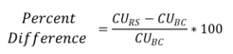
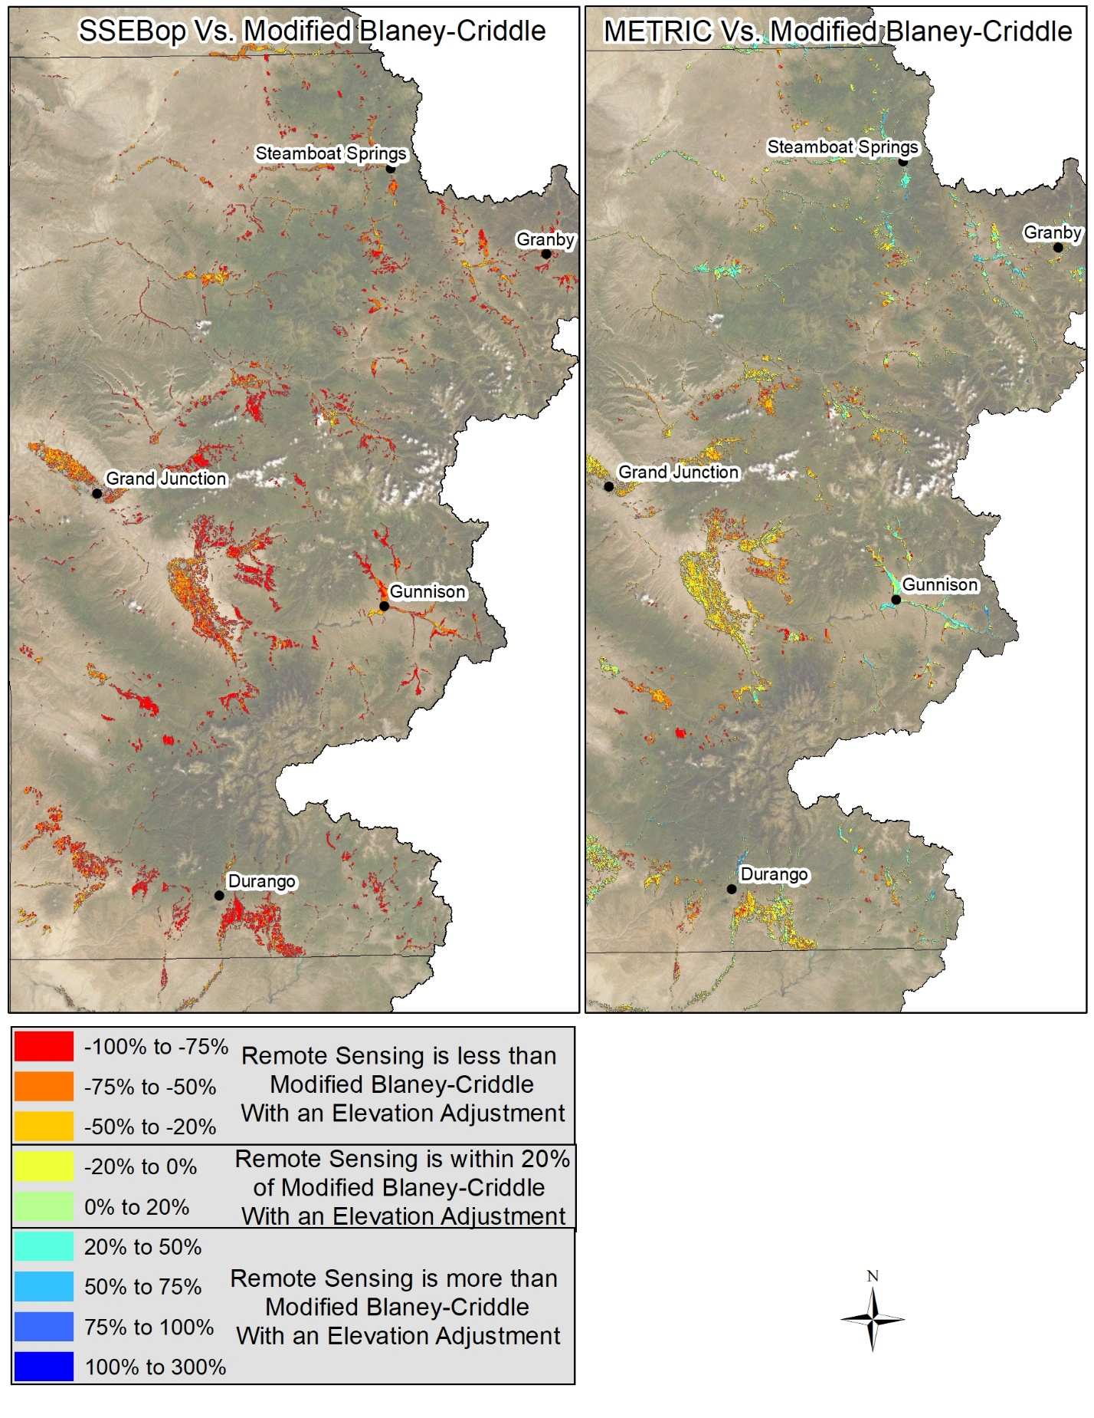
Figure 29. Percent Difference of CU_{irr} - METRIC and SSEBop versus Modified Blaney-Criddle with an Elevation Adjustment in Colorado for 2018
  - 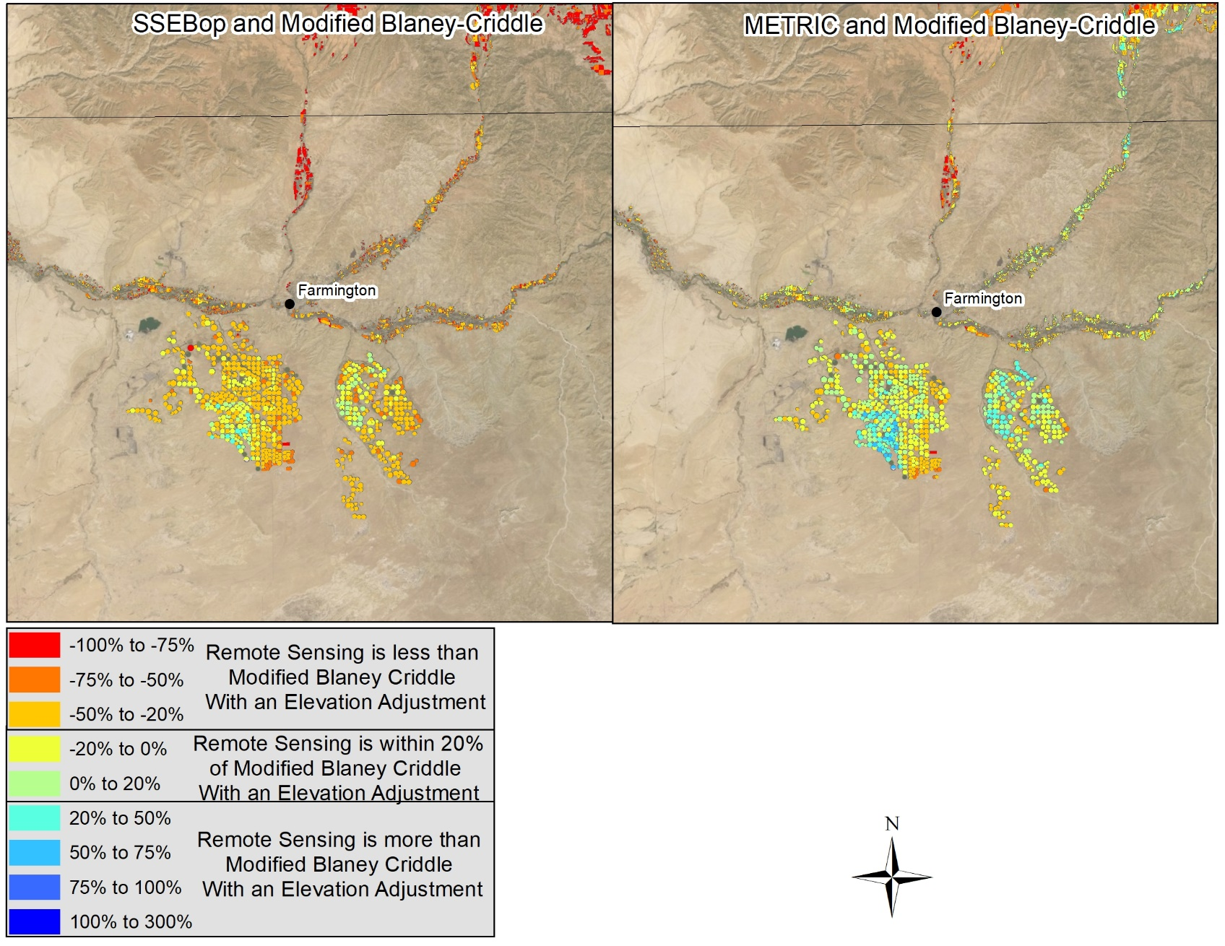
Figure 30. Percent Difference of CUirr - METRIC and SSEBop versus Modified Blaney-Criddle with an Elevation Adjustment in New Mexico for 2018
  - 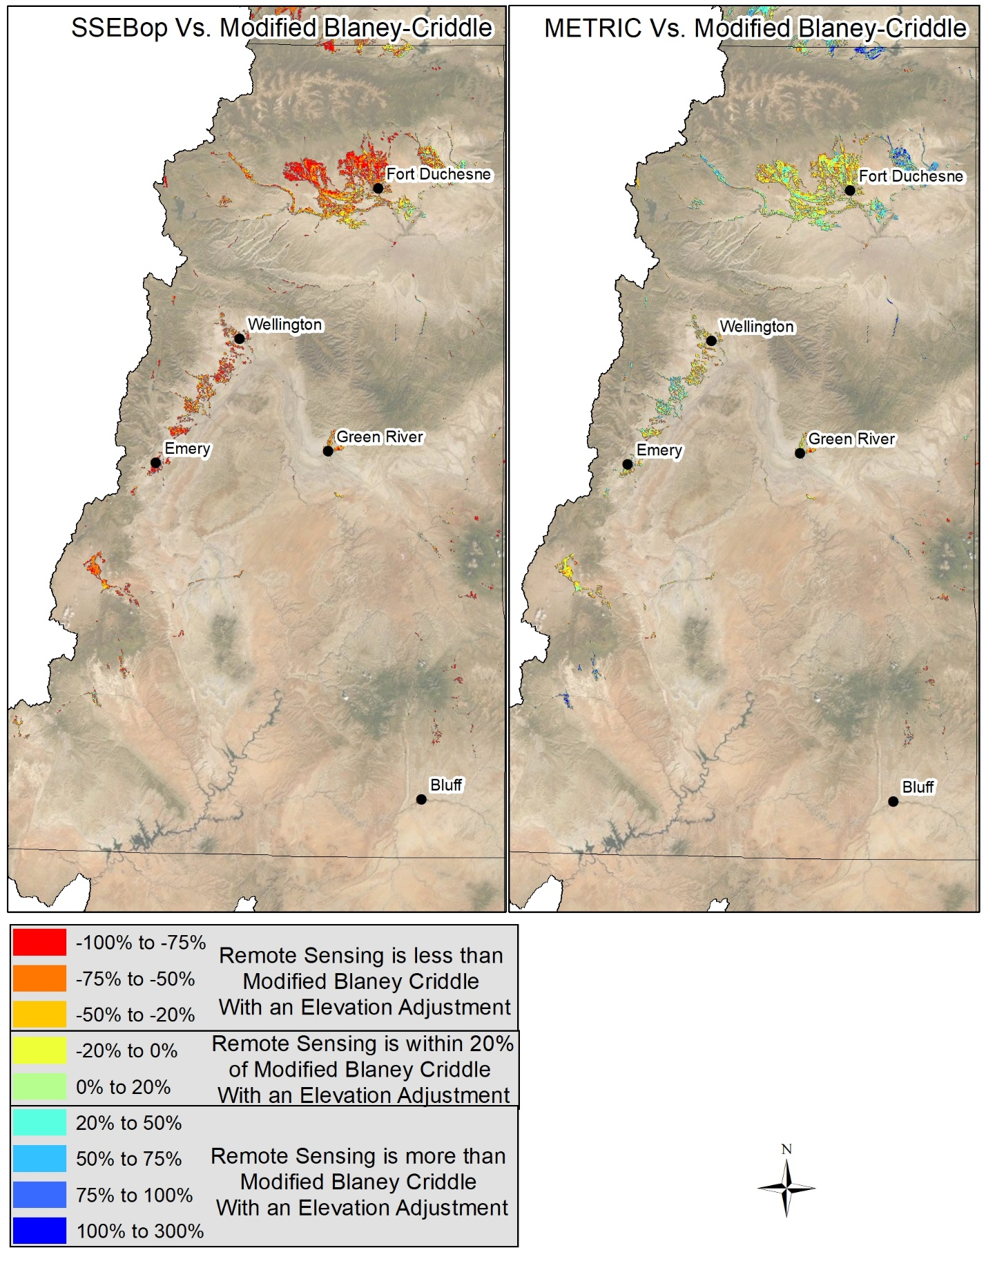
  - Figure 31. Percent Difference of CU_{irr} - METRIC and SSEBop versus Modified Blaney-Criddle with an Elevation Adjustment in Utah for 2018
  - 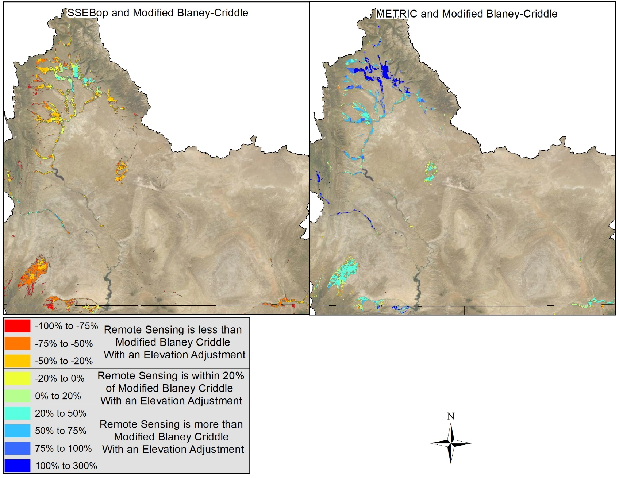
Figure 32. Percent Difference of CUirr - METRIC and SSEBop versus Modified Blaney-Criddle with an Elevation Adjustment in Wyoming for 2018
Figures 33 to 36 show CU_{irr} percent differences between Penman-Monteith and the Remote Sensing methods by state. The following observations are based on Figure 33 through 36.
- METRIC CU_{irr} estimates were not typically greater or less than Penman-Monteith. Overall the two methods seem to report similar ET in all four states and increases in elevation did not seem to cause large differences between the two methods.
- SSEBop was generally less than Penman-Monteith over the entire UCRB. SSEBop was most similar to Penman-Monteith in New Mexico. SSEBop was much lower than Penman-Monteith across Colorado. As with Modified Blaney-Criddle with an Elevation Adjustment, some of the difference between SSEBop and Penman-Monteith may be due to the underestimated shortages applied in Colorado using the indicator gage method.
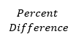
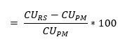
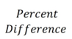
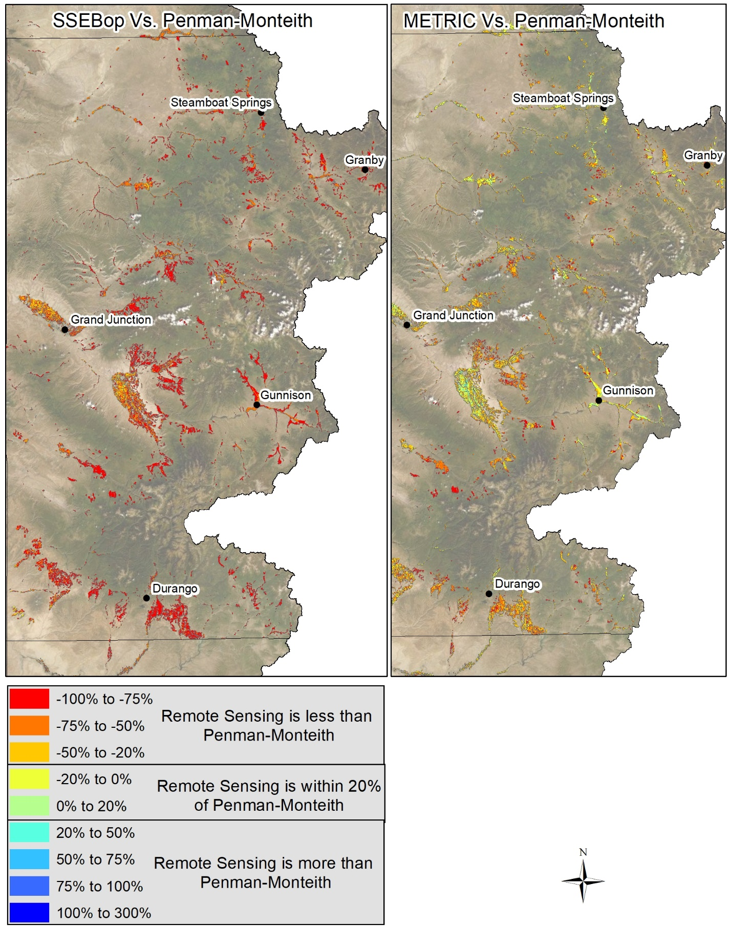
Figure 33. Percent Difference of Consumptive Use from Irrigation from METRIC and SSEBop versus Penman-Monteith in Colorado for 2018

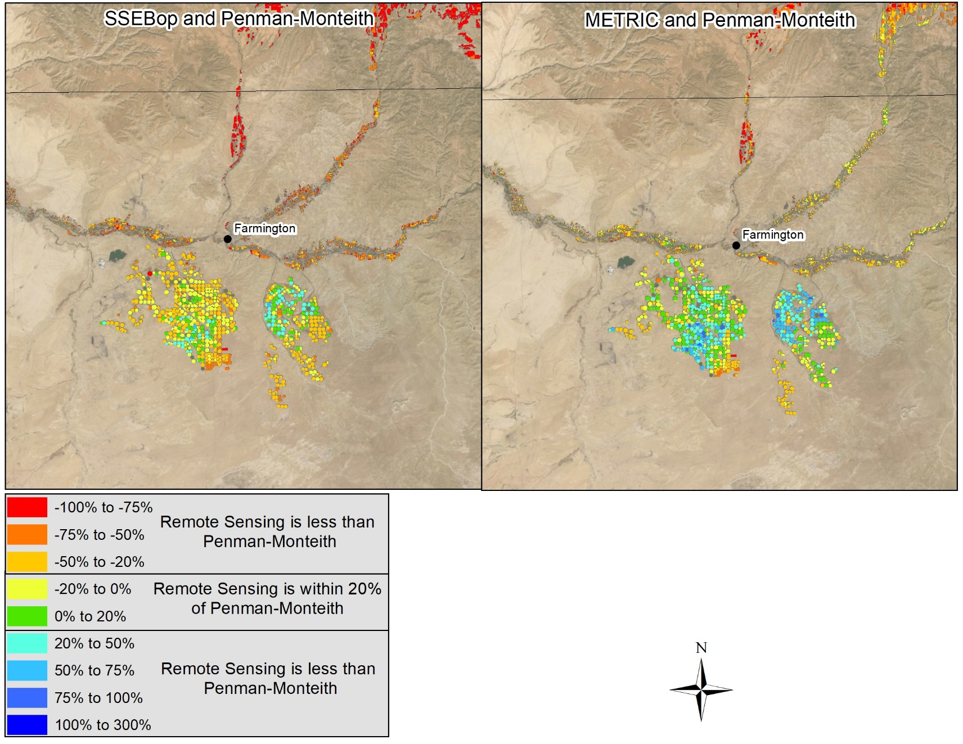
Figure 34. Percent Difference of Consumptive Use from Irrigation from METRIC and SSEBop versus Penman-Monteith in New Mexico for 2018
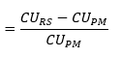
  - 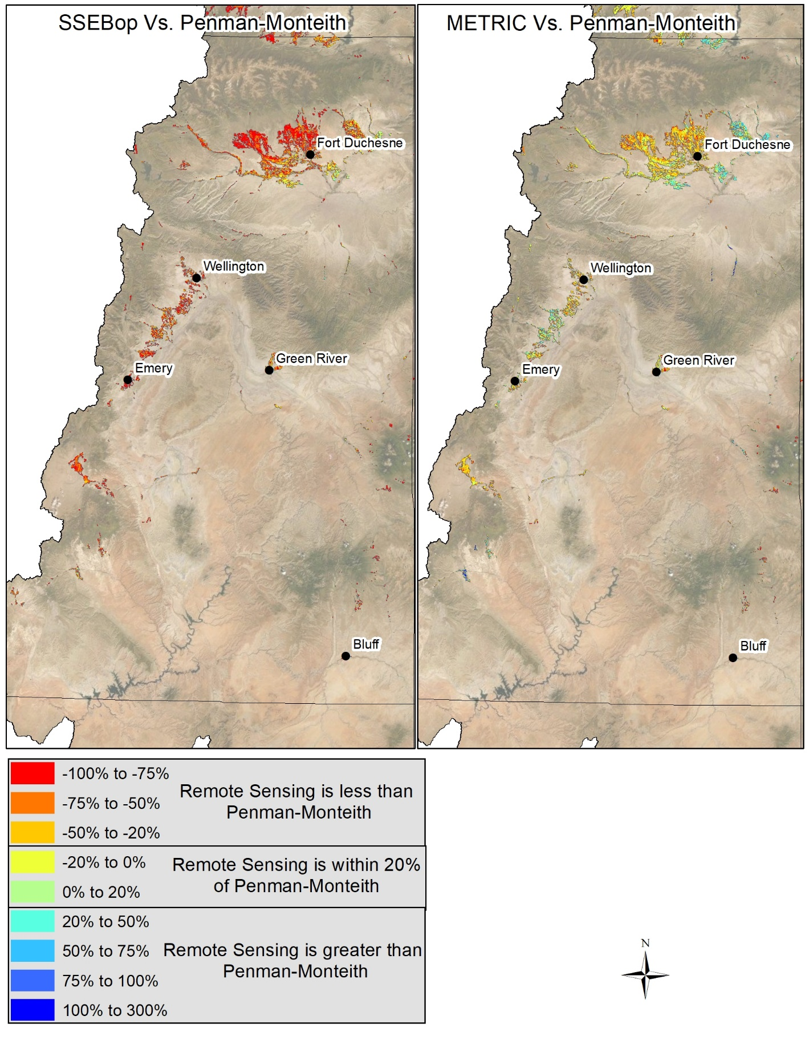
Figure 35. Percent Difference of Consumptive Use from Irrigation from METRIC and SSEBop versus Penman-Monteith in Utah for 2018

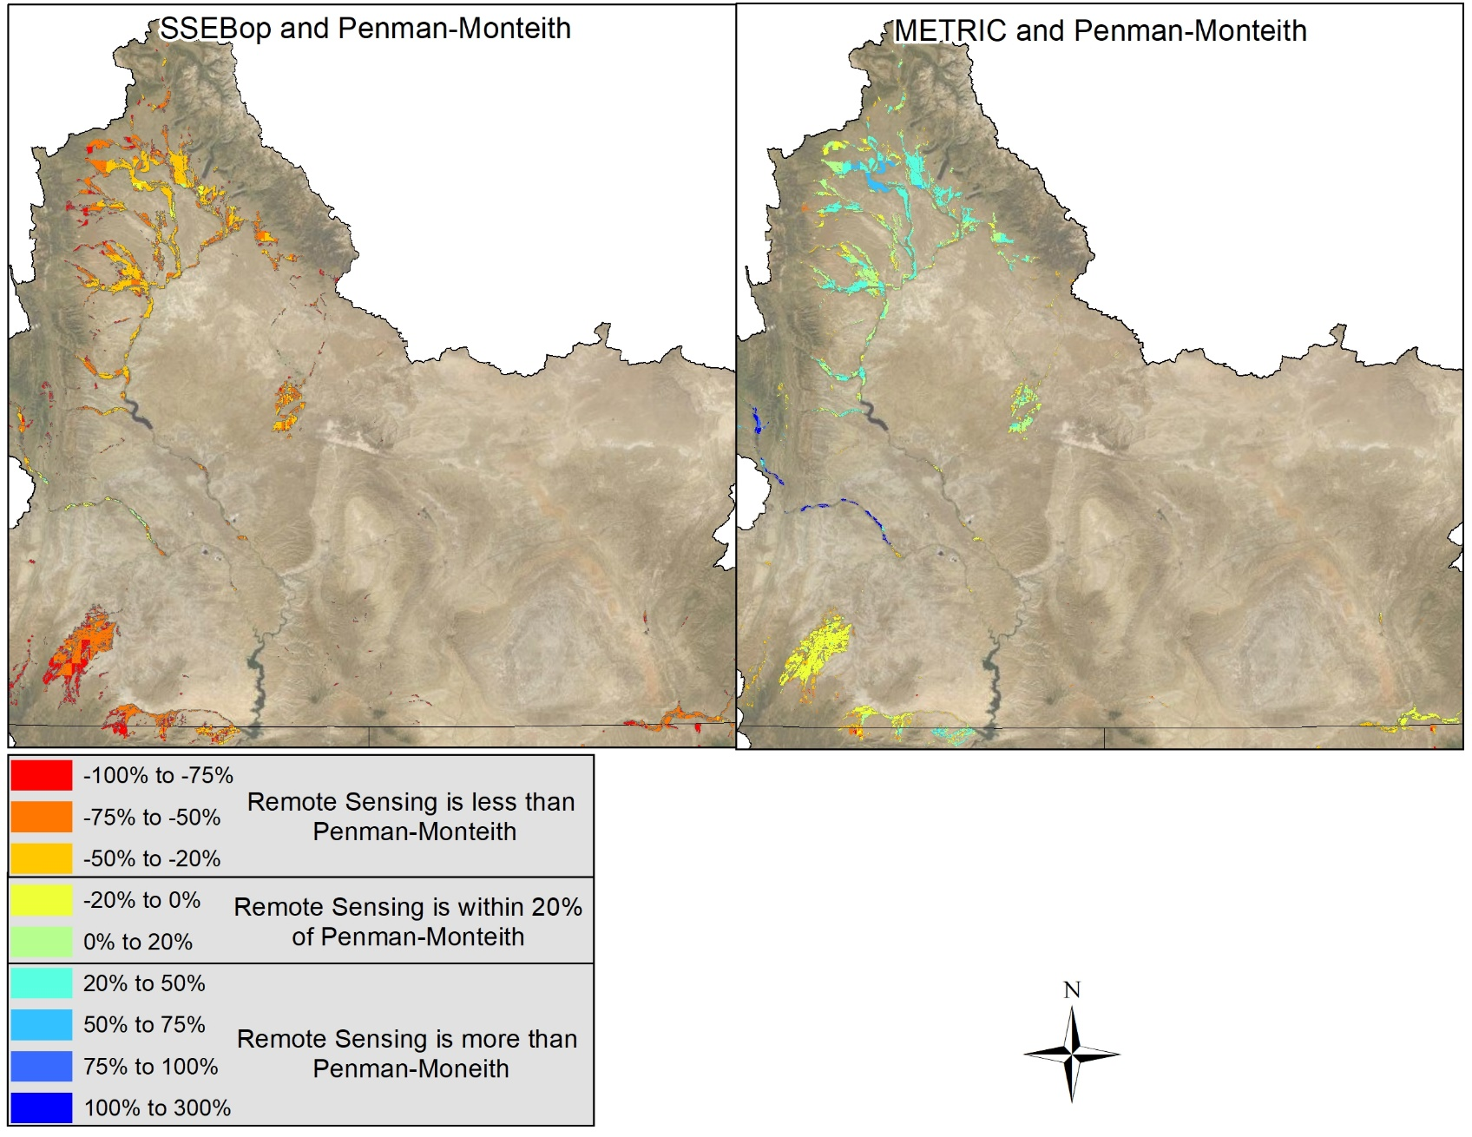
Figure 36. Percent Difference of Consumptive Use from Irrigation from METRIC and SSEBop versus Penman-Monteith in Wyoming for 2018

4.3 CCM Comparison to Modified Blaney-Criddle without an Elevation Adjustment
To date, Reclamation’s Consumptive Uses and Losses reporting for the UCRB uses Modified Blaney-Criddle without an elevation adjustment to estimate ET_{p} and CU_{irr}. To understand the potential impacts of moving to another CCM for reporting, this section compares Modified Blaney-Criddle CU_{irr} with and without an elevation adjustment and Penman-Monteith CU_{irr} estimates on a state level and based on elevation bands (i.e., 4,000 to 5,000 feet). Table 12 also shows the percent difference between Modified Blaney-Criddle without an elevation adjustment and the CCM methods investigated in this report. Figure 13 shows total (April to October) CU_{irr} for all three methods at different elevation bands across the UCRB.

As discussed above, the indicator gage method was used to apply shortages to ET_{p} less effective precipitation for each of the CCMs. Therefore, even though the indicator gage method is believed to underestimate shortages especially, in a dryer hydrologic year such as 2018, the application of the method to reduce ET_{p} estimated by each CCM provides a meaningful comparison.

Table 12. Total Crop Consumptive Use from Irrigation by State for CCMS
State | Modified Blaney-Criddle Without an Elevation Adjustment | Modified Blaney-Criddle with an Elevation Adjustment | Penman-Monteith | Percent Difference
 |  |  |  | Modified Blaney-Criddle with an Elevation Adjustment and Blaney-Criddle without an Elevation Adjustment | Penman-Monteith and Blaney-Criddle without an Elevation Adjustment
Colorado | 1,453,745 | 1,766,932 | 2,209,353 | 21.5% | 52.0%
New Mexico | 199,332 | 237,005 | 229,387 | 18.9% | 15.1%
Utah | 599,897 | 712,089 | 882,611 | 18.7% | 47.1%
Wyoming | 298,140 | 375,866 | 539,291 | 26.1% | 80.9%
Total | 2,551,114 | 3,091,891 | 3,860,641 | 21.2% | 51.3%

Figure 37. Total Crop Consumptive Use from Irrigation by Elevation Band

The following observations are based on Table12 and Figure 37:
- Both Modified Blaney-Criddle with an Elevation Adjustment and Penman-Monteith results in increased basin-wide total CU_{irr} compared to historical estimates using Modified Blaney-Criddle without an elevation adjustment, as both methods estimate higher ET_{p}.
- Irrigated acreage at higher elevations show the largest increase in CU_{irr} from Modified Blaney-Criddle without an elevation adjustment compared to both the Modified Blaney-Criddle with an Elevation Adjustment and Penman-Monteith methods.
- The majority of the UCRB’s CU_{irr} occurs within the 6,000 to 7,000 feet elevation band.

4.4 Vernal EC Tower 2017 to 2018 Comparison
In 2017 the Vernal EC Tower was operational from June 10 to October 31. Sensor malfunctions and climatic conditions caused the EC Tower data to be rated as “Poor” or “Gap Filled” 21 percent of the time, with the majority of the gap filled data occurring from late June to early July. In 2018 the Vernal EC Tower was operational from April 1 to October 31 and had only 7 percent of its data classified as “Poor” and required no data gap filling.

2017 results showed SSEBop with the closest results to the EC Tower at daily, monthly and growing season time steps. In 2018, METRIC more closely matched the EC Tower at daily, monthly and growing season time steps at the Vernal EC Tower and the other tower locations. Figure 38 compares the 2017 and 2018 Remote Sensing monthly results at the Vernal EC Tower.

Figure 38. Monthly Remote Sensing results at the Vernal EC Tower for 2017 and 2018

5.0 Cost and Time Comparison
Annual processing time and costs for the different methods used to estimate Crop Consumptive Use from irrigation are shown in Table 13. Annual processing time assumes that the person doing the processing is knowledgeable and highly experienced, and no training is required. Time estimates were provided based on man-hours. In order to keep the costs comparable, it was assumed that the producer of each method bills at $150 an hour and works a typical 8-hour day. Other costs associated with Remote Sensing methods include data storage costs. These costs will be revised again in the 2019 report.

Table 13. Annual Time and Costs for Methods based on 2018
Method | Annual Processing Time (days)¹ | Post Processing Time (days)² | Annual Labor Costs
METRIC | 94.3 | 3 | $ 116,760
SSEBop | 15 | 3 | $ 21,600
Modified Blaney-Criddle | ~2.5 | 1 | $ 4,200
Penman-Monteith | 40 | 2 | $50,400
- Estimates do not account for time required to develop documentation
- Post Processing Time is the amount of time Wilson Water Group spent on post processing of
datasets received from other contractors

The primary purpose of determining the cost of the various methods is to compare the potential costs to develop information for the Consumptive Uses and Losses Report. As such, the EC Tower purchasing and operating costs are not included, as the EC Towers are being used to select the most appropriate method only and are not intended to be operated into the future.

Labor and storage costs are not the only costs for each method. The Penman-Monteith, SSEBop and METRIC models require weather data to calculate ET_{r}. Reference ET for these methods requires more weather data than NOAA stations measure. All four of the UCRB states have agricultural climate station networks that require state and often federal funds to operate. Phase 2 of the Study identified locations where additional climate stations were required, and funding was secured by Reclamation for purchase and installation. There is on-going operation and maintenance costs that are not included, as the costs are consistent regardless of the methodology selected.

The costs and time estimates in Table 13 might change as ET data become more widely available. It is possible that in the future SSEBop ET products will be made freely available, as USGS continues to assess the accuracy and reliability of the data for public use. More information on the resources required for SSEBop is provided in Appendix B. In addition, a version of METRIC on Google Earth Engine, named EEFlux, is freely available for application and can be used in the future to produce ET maps for satellite overpass days. Accuracy of EEFlux is expected to be somewhat less than the METRIC accuracy due to the automated calibration process used with EEFlux.

Typically, developing the consumptive use numbers for Reclamation’s Consumptive Uses and Losses Report takes around eight days to both compile the necessary data and calculate the Modified Blaney-Criddle results. If Reclamation switched to a Remote Sensing method for the Consumptive Uses and Losses report, the amount of processing time and costs would increase significantly. Switching to Penman-Monteith for estimated ET_{p}, would increase the processing time by about 34 days, due to the large amount of climate data required to be collected and quality-controlled for Penman-Monteith. Switching to Penman-Monteith would also require more time in the first few years, as there is a learning curve to running and operating the ET Demands model used to determine ET and to potentially refine crop coefficient curves and growing season start and ending dates (see Appendix D). Reclamation has already made the investment in states’ agricultural climate networks, but would have to continue to help state networks pay for operation and maintenance of station data if it switched to a Remote Sensing or Penman-Monteith method.

6.0 Summary
The following summarizes observations from the EC Tower comparisons:
- SSEBop CU_{irr} tended to result in lower ET_{a} and CU_{irr} than other methods at all EC Towers.
- METRIC matched up fairly well to the EC Towers at both the daily and monthly time step and was within 20 percent for the growing season for every tower location.
- METRIC results were closer to the EC Tower measurements than SSEBop results at all four EC Towers despite the EC Towers having different crop types, elevations, irrigation methods, and climatic conditions.
- Penman-Monteith was within 10 percent of the Palisade, Vernal and Big Piney EC Towers for the growing season.
- Both CCMs estimated CU_{irr} that varied significantly from the EC Towers estimates during some months. Monthly variation may be partially due to the difficulty in CCMs predicting when cuttings occur or due to the shortages applied by the Indicator gage method.

The following summarizes the basin-wide consumptive use comparison:
- Basin-wide METRIC results fell within the middle of all four methods.
- SSEBop CU_{irr} tended to result in lower CU_{irr} than other methods basin wide.
- Both Penman-Monteith and Modified Blaney-Criddle with an Elevation Adjustment resulted in higher CU_{irr} estimates compared to Remote Sensing methods in all states except Wyoming; likely due to an underestimation of shortages from the indicator gage method.

2018 was a hydrologically dry year in Colorado, Utah, and New Mexico, while Wyoming experienced an average snowpack. The CCMs reported basin wide CU_{irr} results that were higher than the Remote Sensing methods. It is likely that the Indicator gage method did not apply enough shortages in 2018, especially in Colorado. With the Indicator gage method, Colorado shortages rarely go above 8 percent. Although the large irrigation projects in Colorado, including the Grand Valley Project and the Uncompahgre Project, generally receive a full supply; much of the other irrigated agriculture, especially on smaller tributaries, experience water shortages every year. A map of irrigated lands impacted by the indicator gage method is included in Appendix E. If the indicator gage method continues to be used, the shortages applied to different areas need to reassessed.

Using the Penman-Monteith method for estimating ET_{p} would increase the consumptive use from irrigation reported in the Consumptive Uses and Losses Report. It would also increase the amount of time and cost required to develop CU_{irr} estimates. Penman-Monteith is the widely accepted standard for calculating reference ET, and it performed well at all four EC Tower locations. If the UCRB states adopt the method, it is important to assess the impact it would have on future UCRB depletion estimates.

METRIC and SSEBop both require significant time and money, but provide field-specified spatial ET_{a} information without the need for ditch-level water supply information. SSEBop is the more automated of the two methodologies, requires the least amount of calibration, and takes significantly less time to complete than METRIC, but reported relatively low ET_{a} estimates at all four tower locations. METRIC requires more time and calibration; however it provided results closer to EC Towers results in 2018. Analyzing 2019 results for each method may provide a more complete comparison of the Remote Sensing methods at all four EC Tower locations.

8.0 Next Steps
The 2018 growing season provided valuable information regarding ET_{a} and CU_{irr} comparisons at all four EC Towers and basin wide. Comparing 2017 and 2018 results showed how the methods react in differing water supply years. Comparing results at the four EC Towers in the 2019 growing season will be critical to determine if the conclusions are consistent. 2019 will also provide another opportunity to improve the models. For example, SSEBop is currently investigating the relatively lower estimations observed in 2018 results.

References
Alfieri, J.G, Kustas, W.P., Prueger, J.H., Hipps, L.E., Chavez, J.L., French, A. N. and S.R. Evett.
2011. J. Atmos. Oceanic Tech., 28: 1390-1406.

Allen, R. G., Pereira, L. S., Howell, T. A., & Jensen, M. E. 2011. Evapotranspiration information reporting: I. Factors governing measurement accuracy. Agricultural Water Management, 98(2011), 899-920.

Allen, R.G., Tasumi, M., Trezza, R., 2007a. Satellite-Based Energy Balance for Mapping Evapotranspiration with Internalized Calibration (METRIC) – Model. J. Irrig. Drain Engr., 133(4), 380-394.

Allen, R.G., Tasumi, M., Morse, A., Trezza, R., Wright, J.L., Bastiaanssen, W., Kramber, W., Lorite, I., Robison, C.W., 2007b. Satellite-Based Energy Balance for Mapping Evapotranspiration with Internalized Calibration (METRIC) – Applications. J. Irrig. Drain Engr., 133(4), 395-406.

American Society of Civil Engineers (ASCE) Manual 70 – Evaporation, Evapotranspiration, and Irrigation Requirements (1990)

American Society of Civil Engineers (ASCE) Manual 70 – Evaporation, Evapotranspiration, and Irrigation Requirements (2016)

Baldocchi, D.D. 2003. Assessing the eddy covariance technique for evaluating carbon dioxide
exchange rates of ecosystems: past, present and future. Global Change Biology, 9(4):
p. 479-492.

Gowda, P. H., Senay, G. B., Howell, T. A., & Marek, T. H. 2009. Lysimetric evaluation of simplified surface energy balance approach in the Texas High Plains. Appl. Eng. Agric., 25(5), 665-669. https://doi.org/10.13031/2013.28855

Hipps, L. 2018. Uncertainity of Eddy Covariance Estimates of Water Vapor Flux.

Lee, X., W. Massman, and B. Law. 2006. Handbook of micrometeorology: a guide for surface
flux measurement and analysis. Vol. 29. 2006: Springer Science & Business Media.

Kosugi, Y. and M. Katsuyama M. 2007. Evapotranspiration over a Japanese cypress forest. II.
Comparison of the eddy covariance and water budget methods. J. Hydrol., 334: 305-311.

Pochop, L.O., Borrelli, J., Burman, R. 1983. Elevation – A bias Error in SCS Blaney Criddle ET Estiamtes.

Scott, R.L. 2010. Using watershed water balance to evaluate the accuracy of eddy covariance
evaporation measurements for three semiarid ecosystems. Agric. For. Meteorol., 150: 219-225.

Senay, G.B. (2018). Satellite Psychrometric Formulation of the Operational Simplified Surface Energy Balance (SSEBop) Model for Quantifying and Mapping Evapotranspiration. Applied Engineering in Agriculture 34(3): 555-566. doi:10.13031/aea.12614.

Senay, G. B., Schauer, M., Friedrichs, M., Velpuri, N. M., & Singh, R. K. (2017). Satellite-based water use dynamics using historical Landsat data (1984–2014) in the southwestern United States. Remote Sensing of Environment, 202, 98-112. http://dx.doi.org/10.1016/j.rse.2017.05.005

Senay, G.B., Friedrichs, M., Singh, R.K., Velpuri, N.M. 2016. Evaluating Landsat 8 evapotranspiration for water use mapping in the Colorado River Basin: Remote Sensing of Environment. 185:171-185. https://doi.org/10.1016/j.rse.2015.12.043.

Senay, G.B., Bohms, S., Singh, R.K., Gowda, P.H., Velpuri, N.M., Alemu, H., Verdin, J.P. 2013. Operational evapotranspiration mapping using Remote Sensing and weather
datasets: a new parameterization for the SSEB approach. J. Am. Water Res. Assoc.
49:577–591.

Senay, G. B., Budde, M., Verdin, J. P., & Melesse, A. M. (2007). A Coupled Remote Sensing and Simplified Surface Energy Balance Approach to Estimate Actual Evapotranspiration from Irrigated Fields. Sensors, 7, 979-1000.

Twine, T.E., Kustas, W.P., Norman, J.M., Cook, D.R., Houser, P.R., Meyers, T.P., Prueger, J.H.,
Starks, P.J., and M.L. Wesely. 2000. Correcting eddy covariance flux measurements over a grassland. Agric. For. Meteorol., 103:279-300

USDA, Soil Conservation Service, April 1967. Irrigation Water Requirements, Technical Release No 21.

Velpuri, N. M., Senay, G. B., Singh, R. K., Bohms, S., & Verdin, J. P. 2013. A comprehensive evaluation of two MODIS evapotranspiration products over the conterminous United States: Using point and gridded FLUXNET and water balance ET. Remote Sensing Environ., 139, 35-49. https://doi.org/10.1016/j.rse.2013.07.013

